**CSE523 Machine Learning**

**Prof. Mehul Raval**

**Product Classification using their Ingredient**

**Week 6 Report**

| **Name** | **Enrolment Number** |
| --- | --- |
| Aharnish Pithva | AU2040022 |
| Jevin Jivani | AU2040051 |
| Astha Bhalodiya | AU2040067 |
| Yug Patel | AU2040181 |

**1) Tasks Performed in the week.**

During the past week, we focused on implementing the cosine similarity algorithm as part of our machine learning (ML) project. We started by thoroughly understanding the mathematical concepts behind cosine similarity, which measures the similarity between two vectors in a multi-dimensional space. We then implemented the algorithm in Python, utilising relevant libraries and tools such as NumPy and scikit-learn.

**2) Outcomes of the tasks performed.**

The implementation of the cosine similarity algorithm proved to be successful and yielded positive outcomes. We could effectively compute the similarity between pairs of vectors, which is a crucial step in many ML applications, such as recommendation systems, document similarity analysis, and image recognition. The cosine similarity algorithm provided meaningful results and insights for our project, contributing to the overall progress and success of the ML project. The outcomes of this task have enhanced our understanding of similarity measures and their applications in machine learning, which will also be valuable in future projects.

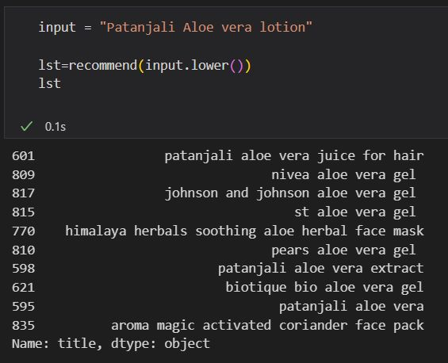

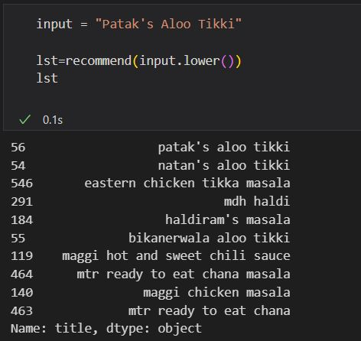

**3) Tasks to be performed in the upcoming week.**

Based on the progress made in the past week, we plan to focus on implementing Principal Component Analysis (PCA) in the upcoming week. PCA is a dimensionality reduction technique used to analyse and visualise data by transforming it into a lower-dimensional space while preserving its essential features. we will start by studying the underlying concepts of PCA, including eigenvalues, eigenvectors, and covariance matrices. we will then implement the PCA algorithm in Python, using relevant libraries and tools, and integrate it into our ML project. we will ensure that the implementation is efficient, accurate, and well-tested. We will also evaluate the performance of PCA in our project and analyse the results to gain insights and make further improvements. Overall, implementing PCA will be a crucial step in reducing the data's dimensionality and improving our ML project's efficiency and effectiveness.